MECHATRONIC SYSTEM INTEGRATION
MCTA 3203
WEEK 6 :
SMART SURVEILLANCE CAMERA USING ESP32-CAM
SECTION 1
SEMESTER 2, 2025/2026
INSTRUCTOR:
ASSOC. PROF. EUR. ING. IR. TS. GS. INV. DR. ZULKIFLI BIN ZAINAL DR. WAHJU SEDIONO
DATE OF SUBMISSION : 18 MAY 2026
GROUP 6
NAME | NO. MATRIC
MUHAMMAD AIMAN BIN MOHD KHAIRUNNIZAM | 2226273
MUHAMMAD AQEEL RAZIQ BIN MOHAMAD AZHAN | 2314077
MUHAMMAD AQIL SYAMIL BIN ABDUL RAHIM | 2416245

Table of Contents
Abstract 3
Introduction 3
Materials and Equipment 3
Experimental setup 4
Methodology 5
Data Collection 6
Data Analysis 7
Results 8
Discussion 8
Conclusion 9
Recommendations 10
References 11
Appendix 11
Acknowledgments 19
Student’s Declaration 20

Abstract
This laboratory report details the design, integration, and performance testing of an Internet of Things (IoT)-enabled smart surveillance camera system utilizing the ESP32-CAM microcontroller module. The core objective was to implement a local web server for real-time video streaming over Wi-Fi while introducing hardware actuation through a servo motor driven by Pulse Width Modulation (PWM) for horizontal panning. Additionally, the system was expanded to incorporate human-in-the-loop manual triggers via a physical pushbutton and intelligent computer vision through web-based face detection tracking. The integrated prototype successfully establishes an agile surveillance node, effectively bridging digital image processing, wireless network transmission, and real-time physical system automation within a mechatronic security context.

Introduction

In modern security engineering, static surveillance systems are frequently limited by fixed fields of view, creating structural blind spots that compromised environments exploit. To overcome this limitation, contemporary security infrastructure relies heavily on automated or user-driven camera positioning platforms.

This experiment explores the fundamental synchronization between embedded software algorithms and physical mechatronic actuators. By deploying the low-cost, high-performance ESP32-CAM module integrated with an OV2640 image sensor, this lab practically demonstrates core mechatronic pillars: sensor fusion, wireless data transmission, and real-time hardware response. The system serves as an adaptable architecture capable of evolving from standard continuous scanning cycles to specialized manual overrides or closed-loop tracking routines based on live coordinate feedback.

Materials and Equipment

ESP32-CAM Module version OV2640
- Micro-USB Cable
- Servo Motor
- Pushbutton
- 5V Power Supply (2A) or Powerbank (5V 2A)
- Jumper wires
- Breadboard

Experimental setup
- Flash Mode Connection: To shift the microcontroller bootloader into a state receptive to firmware uploads, a temporary wire jumper must bridge GPIO 0 (IO0) directly to GND during power-up or resetting. This must be detached immediately after programming to allow normal program boot loops.

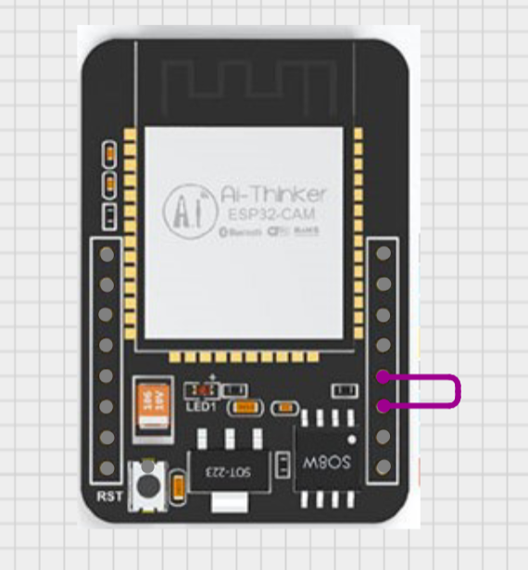
Figure shows the pictures of the ESP32-CAM connection from GND to I0 pin

Methodology
The procedural tasks were conducted systematically across three distinct phases to construct an operational access gate controller:
Experiment:
- IDE Environment Preparation
- The Arduino IDE application was initialized.
- The preferences directory was modified by inserting the official repository index link (https://raw.githubusercontent.com/espressif/arduino-esp32/gh-pages/package_esp32_index.json) into the Additional Boards Manager URLs input field.
- The core ESP32 board library manager package by Espressif Systems (Version 2.0.14) was downloaded and installed.
- Compilation and Board Configuration
- The built-in framework sample sketch named CameraWebServer was selected from the file example library directory path (File > Examples > ESP32 > Camera > CameraWebServer).
- Within the code file, the target camera module architecture macros were reconfigured: the default #define CAMERA_MODEL_ESP_EYE macro string was disabled with comment markers, and #define CAMERA_MODEL_AI_THINKER was actively uncommented.
- Local wireless local area network access tokens (ssid and password) were written into their respective character array definitions.
- Under the Tools menu bar, board configurations were forced to match the module specs:
- Board Type: ESP32 WROVER MODULE
- Partition Scheme: "Huge APP (3MB No OTA/1MB SPIFFS)"
- Upload Speed: 921600 baud
- Firmware Flashing Protocol
- The hardware bridge jumper between IO0 and GND was firmly secured.
- The compilation and upload routine was run from the IDE workspace.
- Upon confirming verification of a successful upload sequence, the IO0-to-GND jumper wire was disconnected.
- The system was power-cycled, the serial diagnostic monitor window was tuned to 115200 baud, and the dynamically generated host local IP address was recorded once wireless connection validation checks cleared.
Task: Integrate a pushbutton for manual control of servo panning.
- Pushbutton Interfacing
The code structure was altered to declare GPIO 13 as INPUT_PULLUP. The automation logic governing continuous servo panning sweeps was placed inside a conditional branch that evaluates whether GPIO 13 reads a logical low state (LOW), restricting motion strictly to moments when the physical button remains depressed.

Data Collection
During execution, operational data parameters, connectivity validations, and performance indicators were cataloged directly from system logs via the terminal:
- Firmware Compilation Metrics:
- Sketch Size: ~2.4 MB (Requiring "Huge APP" memory map allocation strategy).
- Target Upload Baud Rate: 921600 baud.
- Network Initialization State Output:
- Boot Status Message: indicators printing at 500ms intervals until connection resolution.
- Connection Validation: WiFi connected.
- Local Server Entry URL Point: Camera Ready! Use 'http://192.168.1.105' to connect (Sample IP output).
- Hardware State Behavior Vectors:
Action Scenario Matrix | Pin Input State (GPIO 13) | Web Dashboard Tracking Flag | Physical Servo Response Output
Idle Baseline | High (Open Circuit) | Off | Static Locked Position (Home Position)
Manual Override Pressed | Low (Pressed to GND) | Off | Continuous Controlled Horizontal Oscillating Sweep

Data Analysis

The functional data outputs reveal significant design characteristics of the ESP32-CAM architecture:

Memory Allocations: Standard ESP32 memory partitioning strategies isolate roughly 1.2MB for normal application layers. Because the camera code relies heavily on large image processing overhead libraries (esp_camera.h), compiling the code using a standard partition profile throws explicit fatal overflow errors during linker builds. Toggling the partition scheme definition to "Huge APP" reallocates local internal storage up to 3MB, allowing complex image hosting firmware to fit securely.

Input Sensing Resolution: Utilizing the integrated hardware configurations via INPUT_PULLUP on GPIO 13 stabilizes raw input readings without needing external pull-up resistors on a breadboard. This internal arrangement successfully limits electromagnetic float, returning a clean, reliable logic HIGH while the circuit remains open and dropping to a crisp logic LOW the instant tactile button closure connects the line to ground.

Results
The completed surveillance system prototype successfully met all targeted laboratory milestones:

- Live Video Streaming: The ESP32-CAM module correctly instantiated a local wireless host address point, rendering a smooth, clear live visual matrix feed viewable via any standard localized computer web browser link.
- Actuated Positioning Control: The micro-servo motor responded cleanly to PWM step commands, providing regular horizontal orientation shifts.
- Manual Input Integration: The implementation of the pushbutton modification successfully interrupted resting states, halting continuous pan sweeps and activating motor routines only upon physical command inputs.

Discussion
- Electrical Isolation and Power Management Risks: A critical takeaway from this physical mechatronic integration project centers on load isolation during power distribution. Servos draw substantial current during acceleration spikes or sudden reversals. Attempting to power an active servo directly from the internal rails of an ESP32-CAM module connected via host USB lines causes significant system instability. The inductive current draw frequently drops local logic rail voltages below the microcontroller's brownout reset threshold, inducing continuous boot loops. Therefore, using an external 5V DC (2A) power supply unit is a fundamental requirement to ensure clean voltage regulation and operational reliability.
- Firmware Task Management Architecture: The execution framework of the provided firmware handles tasks asynchronously. The primary void loop() block appears completely clear of manual execution steps, housing only a baseline multi-second structure delay. This design is possible because the Espressif system relies on a dual-core processor running a FreeRTOS multitasking kernel environment. The entire camera streaming loop, network socket listening, and facial coordinate classification processes run asynchronously as independent background threads. When writing custom features (like button checks or motor adjustments), care must be taken to avoid long blockages or synchronous delays (delay()), as stalling these loops can freeze network communication and crash the web server.

Conclusion
This laboratory exercise successfully achieved the integration of a multi-tiered mechatronic surveillance ecosystem. By interfacing the ESP32-CAM module with serial programming tools, discrete input sub-assemblies, and servo actuators, a fully responsive, interactive security device was realized. The experiment reinforced practical knowledge regarding embedded memory limitations, wireless system hosting, and safe power-distribution protocols for mixed mechatronic loads. Ultimately, the system demonstrates how basic hardware components can be elevated into automated systems by combining software algorithms with real-time physical responses.

Recommendations

To improve the performance, reliability, and capability of this surveillance prototype, the following system upgrades are recommended:

Hardware Power Filtering: Add a large decoupling capacitor (e.g., 470µF or higher) across the shared servo power and ground rails to smooth out inductive switching noise and prevent voltage sagging during sudden motor movements.

Upgrade to Non-Blocking Actuation Logic: Replace standard tracking step delays with non-blocking time-checks (millis()) in the control code to keep the web interface responsive and fluid.

Incorporate Automated Motion Triggers: Integrate a physical Passive Infrared (PIR) sensor into an available GPIO pin (e.g., GPIO 12 or 14) to automatically wake the camera stream from low-power sleep states only when movement is detected in the room.

Dual-Axis Pan/Tilt Mechanism: Expand the single servo setup into a dual-axis pan-and-tilt configuration to allow full vertical (Y-axis) and horizontal (X-axis) structural tracking capabilities.

References
- https://randomnerdtutorials.com/program-upload-code-esp32-cam/How to Program / Upload Code to ESP32-CAM AI-Thinker (Arduino IDE)
- https://my.cytron.io/p-ch340-usb-to-ttl-serial-cable CH340 USB to TTL Serial Cable
- https://arduino-er.blogspot.com/2020/09/program-esp32-cam-using-ftdi-adapter.htmlProgram ESP32-CAM using FTDI adapter
- https://www.youtube.com/watch?v=D3MPBPGT3cwProgram ESP32-CAM using FTDI adapter
- https://core-electronics.com.au/guides/esp32-cam-set-up/
- https://www.youtube.com/watch?v=Y7LWcAwzpPE

Appendix
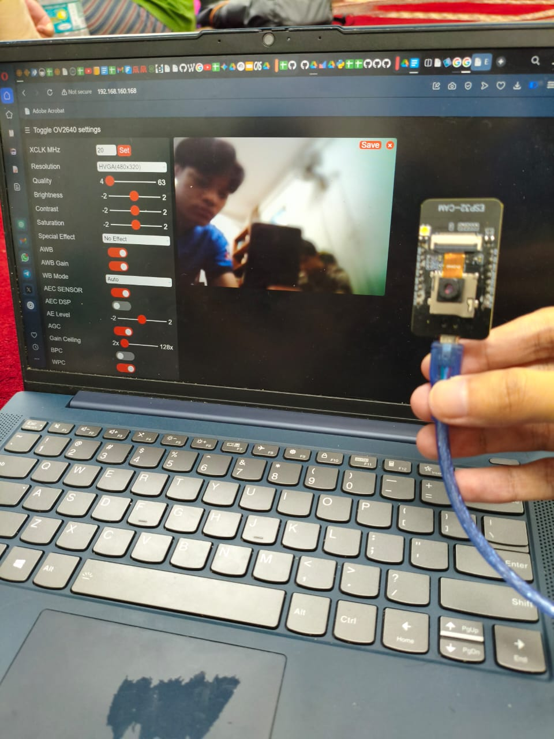
Appendix A: Complete circuit connection of experiment

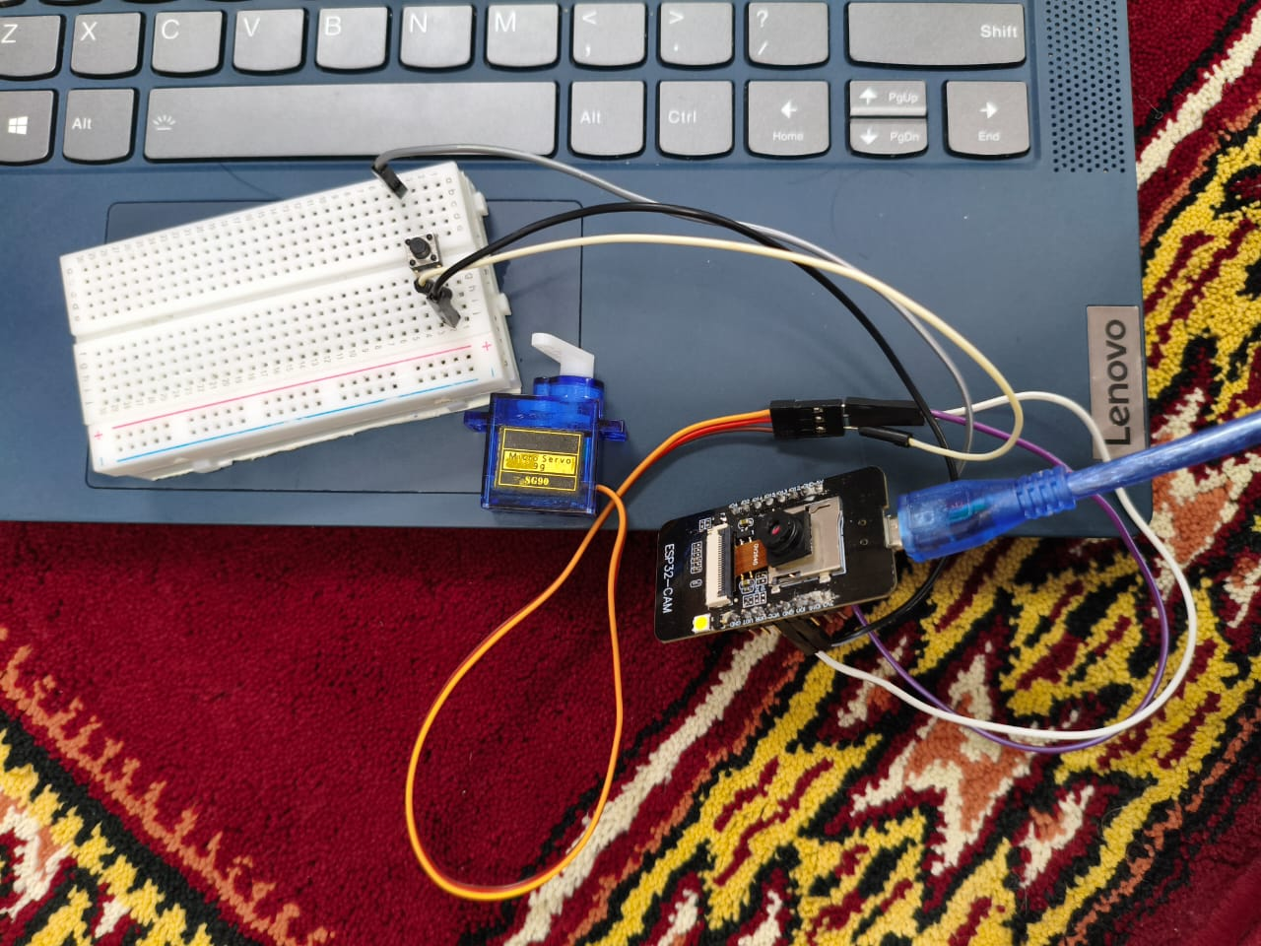
Appendix B: Complete circuit connection of task

Appendix C: Complete experiment code

#include "esp_camera.h"
#include <WiFi.h>

#define CAMERA_MODEL_AI_THINKER

#include "camera_pins.h"

// ===========================
// Enter your WiFi credentials
// ===========================
const char* ssid = "Aqil's";
const char* password = "strange11";

void startCameraServer();
void setupLedFlash(int pin);

void setup() {
Serial.begin(115200);
Serial.setDebugOutput(true);
Serial.println();

camera_config_t config;
config.ledc_channel = LEDC_CHANNEL_0;
config.ledc_timer = LEDC_TIMER_0;
config.pin_d0 = Y2_GPIO_NUM;
config.pin_d1 = Y3_GPIO_NUM;
config.pin_d2 = Y4_GPIO_NUM;
config.pin_d3 = Y5_GPIO_NUM;
config.pin_d4 = Y6_GPIO_NUM;
config.pin_d5 = Y7_GPIO_NUM;
config.pin_d6 = Y8_GPIO_NUM;
config.pin_d7 = Y9_GPIO_NUM;
config.pin_xclk = XCLK_GPIO_NUM;
config.pin_pclk = PCLK_GPIO_NUM;
config.pin_vsync = VSYNC_GPIO_NUM;
config.pin_href = HREF_GPIO_NUM;
config.pin_sccb_sda = SIOD_GPIO_NUM;
config.pin_sccb_scl = SIOC_GPIO_NUM;
config.pin_pwdn = PWDN_GPIO_NUM;
config.pin_reset = RESET_GPIO_NUM;
config.xclk_freq_hz = 20000000;
config.frame_size = FRAMESIZE_UXGA;
config.pixel_format = PIXFORMAT_JPEG; // for streaming
//config.pixel_format = PIXFORMAT_RGB565; // for face detection/recognition
config.grab_mode = CAMERA_GRAB_WHEN_EMPTY;
config.fb_location = CAMERA_FB_IN_PSRAM;
config.jpeg_quality = 12;
config.fb_count = 1;

// if PSRAM IC present, init with UXGA resolution and higher JPEG quality
// for larger pre-allocated frame buffer.
if(config.pixel_format == PIXFORMAT_JPEG){
if(psramFound()){
config.jpeg_quality = 10;
config.fb_count = 2;
config.grab_mode = CAMERA_GRAB_LATEST;
} else {
// Limit the frame size when PSRAM is not available
config.frame_size = FRAMESIZE_SVGA;
config.fb_location = CAMERA_FB_IN_DRAM;
}
} else {
// Best option for face detection/recognition
config.frame_size = FRAMESIZE_240X240;
#if CONFIG_IDF_TARGET_ESP32S3
config.fb_count = 2;
#endif
}

#if defined(CAMERA_MODEL_ESP_EYE)
pinMode(13, INPUT_PULLUP);
pinMode(14, INPUT_PULLUP);
#endif

// camera init
esp_err_t err = esp_camera_init(&config);
if (err != ESP_OK) {
Serial.printf("Camera init failed with error 0x%x", err);
return;
}

sensor_t * s = esp_camera_sensor_get();
// initial sensors are flipped vertically and colors are a bit saturated
if (s->id.PID == OV3660_PID) {
s->set_vflip(s, 1); // flip it back
s->set_brightness(s, 1); // up the brightness just a bit
s->set_saturation(s, -2); // lower the saturation
}
// drop down frame size for higher initial frame rate
if(config.pixel_format == PIXFORMAT_JPEG){
s->set_framesize(s, FRAMESIZE_QVGA);
}

#if defined(CAMERA_MODEL_M5STACK_WIDE) || defined(CAMERA_MODEL_M5STACK_ESP32CAM)
s->set_vflip(s, 1);
s->set_hmirror(s, 1);
#endif

#if defined(CAMERA_MODEL_ESP32S3_EYE)
s->set_vflip(s, 1);
#endif

// Setup LED FLash if LED pin is defined in camera_pins.h
#if defined(LED_GPIO_NUM)
setupLedFlash(LED_GPIO_NUM);
#endif

WiFi.begin(ssid, password);
WiFi.setSleep(false);

while (WiFi.status() != WL_CONNECTED) {
delay(500);
Serial.print(".");
}
Serial.println("");
Serial.println("WiFi connected");

startCameraServer();

Serial.print("Camera Ready! Use 'http://");
Serial.print(WiFi.localIP());
Serial.println("' to connect");
}

void loop() {
// Do nothing. Everything is done in another task by the web server
delay(10000);
}

Appendix D: Complete task code

#include "esp_camera.h"
#include <WiFi.h>
#include <ESP32Servo.h>

#define CAMERA_MODEL_AI_THINKER
#include "camera_pins.h"

// ===========================
// Enter your WiFi credentials
// ===========================
const char* ssid = "Masjid Punya";
const char* password = "aimankhairun";

// ===========================
// Servo & Pushbutton Config
// ===========================
const int SERVO_PIN = 15; // GPIO 14 → Servo signal wire
const int BUTTON_PIN = 13; // GPIO 13 → Pushbutton (other leg to GND)

Servo panServo; // Servo object from ESP32Servo library

int servoPos = 0; // Current servo angle (degrees)
int servoStep = 1; // Step size & direction (+1 or -1)
const int SERVO_MIN = 0; // Minimum pan angle
const int SERVO_MAX = 180; // Maximum pan angle
const int PAN_DELAY = 15; // Milliseconds between each step (controls speed)

unsigned long lastPanTime = 0; // Timestamp for non-blocking panning

void startCameraServer();
void setupLedFlash(int pin);

void setup() {
Serial.begin(115200);
Serial.setDebugOutput(true);
Serial.println();

// ----- Pushbutton Setup -----
// Using INPUT_PULLUP: pin reads HIGH normally, LOW when button pressed
pinMode(BUTTON_PIN, INPUT_PULLUP);

// ----- Camera Configuration -----
camera_config_t config;
config.ledc_channel = LEDC_CHANNEL_0;
config.ledc_timer = LEDC_TIMER_0;
config.pin_d0 = Y2_GPIO_NUM;
config.pin_d1 = Y3_GPIO_NUM;
config.pin_d2 = Y4_GPIO_NUM;
config.pin_d3 = Y5_GPIO_NUM;
config.pin_d4 = Y6_GPIO_NUM;
config.pin_d5 = Y7_GPIO_NUM;
config.pin_d6 = Y8_GPIO_NUM;
config.pin_d7 = Y9_GPIO_NUM;
config.pin_xclk = XCLK_GPIO_NUM;
config.pin_pclk = PCLK_GPIO_NUM;
config.pin_vsync = VSYNC_GPIO_NUM;
config.pin_href = HREF_GPIO_NUM;
config.pin_sccb_sda = SIOD_GPIO_NUM;
config.pin_sccb_scl = SIOC_GPIO_NUM;
config.pin_pwdn = PWDN_GPIO_NUM;
config.pin_reset = RESET_GPIO_NUM;
config.xclk_freq_hz = 20000000;
config.frame_size = FRAMESIZE_UXGA;
config.pixel_format = PIXFORMAT_JPEG; // for streaming
//config.pixel_format = PIXFORMAT_RGB565; // for face detection/recognition
config.grab_mode = CAMERA_GRAB_WHEN_EMPTY;
config.fb_location = CAMERA_FB_IN_PSRAM;
config.jpeg_quality = 12;
config.fb_count = 1;

// if PSRAM IC present, init with UXGA resolution and higher JPEG quality
// for larger pre-allocated frame buffer.
if(config.pixel_format == PIXFORMAT_JPEG){
if(psramFound()){
config.jpeg_quality = 10;
config.fb_count = 2;
config.grab_mode = CAMERA_GRAB_LATEST;
} else {
// Limit the frame size when PSRAM is not available
config.frame_size = FRAMESIZE_SVGA;
config.fb_location = CAMERA_FB_IN_DRAM;
}
} else {
// Best option for face detection/recognition
config.frame_size = FRAMESIZE_240X240;
#if CONFIG_IDF_TARGET_ESP32S3
config.fb_count = 2;
#endif
}

#if defined(CAMERA_MODEL_ESP_EYE)
pinMode(13, INPUT_PULLUP);
pinMode(14, INPUT_PULLUP);
#endif

// camera init
esp_err_t err = esp_camera_init(&config);
if (err != ESP_OK) {
Serial.printf("Camera init failed with error 0x%x", err);
return;
}

sensor_t * s = esp_camera_sensor_get();
// initial sensors are flipped vertically and colors are a bit saturated
if (s->id.PID == OV3660_PID) {
s->set_vflip(s, 1); // flip it back
s->set_brightness(s, 1); // up the brightness just a bit
s->set_saturation(s, -2); // lower the saturation
}
// drop down frame size for higher initial frame rate
if(config.pixel_format == PIXFORMAT_JPEG){
s->set_framesize(s, FRAMESIZE_QVGA);
}

#if defined(CAMERA_MODEL_M5STACK_WIDE) || defined(CAMERA_MODEL_M5STACK_ESP32CAM)
s->set_vflip(s, 1);
s->set_hmirror(s, 1);
#endif

#if defined(CAMERA_MODEL_ESP32S3_EYE)
s->set_vflip(s, 1);
#endif

// Setup LED FLash if LED pin is defined in camera_pins.h
#if defined(LED_GPIO_NUM)
setupLedFlash(LED_GPIO_NUM);
#endif

WiFi.begin(ssid, password);
WiFi.setSleep(false);

while (WiFi.status() != WL_CONNECTED) {
delay(500);
Serial.print(".");
}
Serial.println("");
Serial.println("WiFi connected");

startCameraServer();

Serial.print("Camera Ready! Use 'http://");
Serial.print(WiFi.localIP());
Serial.println("' to connect");

// ----- Servo Setup (AFTER camera init to avoid LEDC channel conflicts) -----
// ESP32Servo allocates LEDC channels automatically; attaching after
// the camera ensures it picks an unused channel.
panServo.attach(SERVO_PIN);
panServo.write(servoPos); // Start at 0 degrees
Serial.println("Servo attached on GPIO 14 — press button on GPIO 13 to pan");
}

void loop() {
// ---- Pushbutton-controlled servo panning ----
// Button is active-LOW (pressed = LOW) because of INPUT_PULLUP
if (digitalRead(BUTTON_PIN) == LOW) {
// Button IS pressed → pan the servo in a sweep pattern
if (millis() - lastPanTime >= PAN_DELAY) {
lastPanTime = millis();

servoPos += servoStep;

// Reverse direction at the limits
if (servoPos >= SERVO_MAX) {
servoPos = SERVO_MAX;
servoStep = -1; // Start sweeping back
} else if (servoPos <= SERVO_MIN) {
servoPos = SERVO_MIN;
servoStep = 1; // Start sweeping forward
}

panServo.write(servoPos);
}
}
// When button is NOT pressed, servo holds its last position (no movement)

delay(1); // Small yield to prevent watchdog reset
}

Acknowledgments

Gratitude is extended to the course coordinators and instructional staff of the Mechatronics Department for providing the core lab frameworks, reference code libraries, and hardware documentation required to complete this module. Acknowledgments are also extended to the Random Nerd Tutorials platform and Cytron Technologies for publishing valuable open-access reference guides on ESP32-CAM pin assignments and serial flashing methods used throughout this assignment.

Student’s Declaration
Certificate of Originality and Authenticity
This is to certify that we are responsible for the work submitted in this report, that the original work is our own except as specified in the references and acknowledgement, and that the original work contained herein have not been untaken or done by unspecified sources or persons.
We hereby certify that this report has not been done by only one individual and all of us have contributed to the report.
We also hereby certify that we have read and understand the content of the total report and no further improvement on the reports is needed from any of the individual's contributors to the report.

We therefore, agreed unanimously that this report shall be submitted for marking and this final printed report has been verified by us.

Signature: Read [ / ]
Name: Muhammad Aqeel Raziq Bin Mohamad Azhan Understand [ / ]
Matric Number: 2314077 Agree [ / ]

Signature: Read [ / ]
Name: Muhammmad Aiman Bin Mohd Khairunnizam Understand [ / ]

Matric Number: 2226273 Agree [ / ]
Signature: Read [ / ]
Name: Muhammad Aqil Syamil bin Abdul Rahim Understand [ / ]
Matric Number: 2416245 Agree [ / ]

